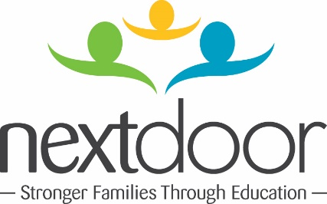
SAMPLE SCRIPT
NEXT DOOR BOOK CHALLENGE

HI. MY NAME IS ---------------------.

ONE OF MY FAVORITE BOOKS FOR YOUNG CHILDREN IS -------.

I LIKE IT BECAUSE ----------------------.

I WANT TO HELP INSPIRE YOUNG READERS AT NEXT DOOR.
THAT’S WHY I’M BUYING THREE CHILDREN’S BOOKS ON NEXT DOOR’S WISH LIST.

I CHALLENGE (FRIEND #1), (FRIEND #2) AND (FRIEND #3) TO DO THE SAME. LET’S BUY BOOKS FOR KIDS!

** Don’t forget to post your message on social media.
** Tag Next Door Milwaukee and your friends when you upload your video.

